**Improved Asymptotic Confidence Interval for the Mean of Poisson Distribution**

Elsidieg Belhaj

Department of Statistics, Faculty of Science, Misurata University

Email: El.belhaj@sci.misuratau.edu.ly

Abstract—The interval estimation of the Poisson parameter $λ$ is commonly presented problem in textbook. The Wald interval is the most frequently used confidence interval for estimating Poisson parameter, and it is based on the asymptotic properties of the sample mean. The Wald interval has a chaotic behaviour in terms of coverage probability, particularly when $λ$ is small. The well known Score interval is recommend by many authors as an alternative to the Wald interval. This paper proposes a new confidence interval for estimating $λ$ that has a better performance in terms of coverage probability than the Wald interval as well as smaller confidence width than the Score interval.

**Keywords**: Poisson distribution, confidence intervals, coverage probability, expected width.

**INTRODUCTION**

Poisson distribution considered to be vitally important in real life applications, where there is a number of events within fixed time or space and having a known rate. For instance, the number of cells infected by a virus within a certain time or the number of particular type of grass seeds that sprout in a patch of earth. So the estimation of Poisson parameter $λ$ attract many researchers and scientists. Interval estimation is one of the basic and fundamental tool of estimating the expected value of Poisson random variables.

In order to construct a Poisson confidence interval, let's assume that $X$ is random variable follows Poisson distribution with parameter $λ$. If one want to form a $100\left(1-α\right)\%$ confidence interval, we need to find two numbers $(L_{x}, U_{x})$ such that

$$P\left(X≥x | λ=L_{x}\right)=\sum_{k=x}^{∞}{(e^{-L_{x}}L_{x}^{k})/k!} ≤\frac{α}{2}$$

and

$$P\left(X≤x | λ=U_{x}\right)=\sum_{k=0}^{x}{(e^{-U_{x}}U_{x}^{k})/k!} ≤\frac{α}{2}$$

Using the above formulas produce a very conservative two sided limits, that is because Poisson distribution is a discrete distribution and skewness of its shape make the problem more complicated.

There exists many different methods for estimating $λ$, and most of them are based on the assumption of asymptotic normality of the sample mean. One of the earliest method is the Wald confidence interval, which is based on inverting the well known Wald large-sample normal test, that is, the interval is the set of $\hat{λ}$  values that leads to the acceptance to the hypothesis $H_{0}:λ=λ_{0}$ against $H_{1}:λ≠λ_{0}$ using the statistic $(\hat{λ}-λ_{0})/√(\hat{λ}/n)$. Therefore, $\left(1-α\right)100\%$ confidence interval for $λ$ is

$$\hat{λ}±z_{\frac{α}{2}} \sqrt{\frac{\hat{λ}}{n}}$$

The Wald confidence interval is used a lot specially in introductory statistics courses, but it has been criticized heavily by many authors for poor performance particularly when sample size is small (e.g., Santner [1], Ghosh [2], Agresti and Coull [3] and Blyth and Still [4]).

Another popular method is called Score confidence interval which is based on inverting the statistic $(\hat{λ}-λ_{0})/√(λ_{0}/n)$. It is easy to show that $\left(1-α\right)100\%$ confidence interval for $λ$ can be written as

$$\hat{λ}+\frac{z_{α/2}^{2}}{2n}±z_{\frac{α}{2}} \sqrt{\frac{\hat{λ}+z_{α/2}^{2}/4n}{n}}$$

This confidence interval was first studied by Wilson [5], and has been shown to perform much better than the Wald interval and recommended by many authors (e.g., Schader and Schmid [6], Agresti and Coull [3] and Brown, Cai and DasGupta [7]).

Several other methods has been proposed to tackle the problem of estimating Poisson mean such as Bartlett [8], Begaud [9], Schwerman [10], Barker [11] and Khamkong [12].

This paper proposes a confidence interval that improves the performance of Wald interval and has an expected length less than the Score interval.

**Improved Wald Confidence Interval**

Let $X_{1}, X_{2}, …, X_{n}$ be an independent and identically Poisson random variables, and let $\overline{X}=\sum_{i=1}^{n}{X_{i}/n}$  be the maximum likelihood estimator (MLE) for Poisson parameter $λ$. Then by the asymptotic efficiency of the MLEs (Cassela [13]) we have

$$\frac{\sqrt{n}\left(\overline{X}-λ\right)}{\sqrt{λ}} \underset{→}{D} N(0, 1)$$

Where $\underset{→}{D}$ means converges in distribution. The main idea now is to shift the estimator to the right by the quantity $z_{α/2}/n$ to encounter the skewness of the distribution specially when the sample size is small. Since $\overline{X}+z_{α/2}/n$ is asymptotically unbiased estimator of $λ$, the quantity $\sqrt{n}\left[\left(\overline{X}+\frac{z_{α/2}}{n}\right)-λ\right]/\sqrt{λ}$ converges in distribution to the standard normal distribution.

Suppose further that ${\hat{σ}}^{2}=\overline{X}+{z_{α/2}}/{3n}$  and we know that $σ^{2}=λ$, then

$$P\left(\left| {\hat{σ}}^{2}- σ^{2}\right|>ε\right)≤\frac{E{\left( {\hat{σ}}^{2}-σ^{2}\right)}^{2}}{ε^{2}}= \frac{{σ^{2}}/n+ z_{α/2}^{2}/9n^{2} }{ε^{2}} →0 as n→∞$$

Therefore, ${\hat{σ}}^{2}\underset{→}{P}σ^{2}$ in probability. Hence, by Slutsky’s theorem (Cassela [13]), we have

$$\frac{\sqrt{n}\left[\left(\overline{X}+\frac{z_{α/2}}{n}\right)-λ\right]}{\sqrt{{\hat{σ}}^{2}}} \underset{→}{D} N(0, 1)$$

Now by simple algebraic steps, we end up by proposing $\left(1-α\right)100\%$ approximate confidence interval which called the Improved Wald confidence interval as follows

$$\overline{X}+\frac{z_{α/2}}{n}±z_{\frac{α}{2}} \sqrt{\frac{\overline{X}+z_{α/2}/3n}{n}}$$

One can consider coverage probability to study the performance of an interval, where the coverage probability is calculated by the equation

$$CP_{λ}=\sum_{k=0}^{∞}{I_{[ L(k), U(k)]}\frac{e^{-λ}λ^{k}}{k!}}$$

Where

$$I= \left\{\begin{matrix}1, λ∈[ L(k), U(k)] \\ 0, λ∉[ L(k), U(k)]\end{matrix}\right.$$

Another measure for the accuracy of a confidence interval is the expected length or width which is calculated by the equation

$$EW_{λ}=\sum_{k=0}^{∞}{\left[U(k)-L(k)\right]\frac{e^{-λ}λ^{k}}{k!}}$$

**RESULTS AND DISCUSSION**

In order to examine the performance of the Improved Wald interval, the coverage probability is calculated and plotted for $λ∈[0.1, 50]$ as shown in Figure 1(a). Note that the new method has an actual coverage probability about 95% when $λ>0.77$, whereas the Wald interval is quite chaotic for $λ<20$, see Figures 1(a)(b). The performance of the new confidence interval improved dramatically for the nominal 99% (Figure 2(a)). It is actually outperform the Score and the Wald interval, where the latter is very chaotic even for $λ>20$ ( see Figure 2(b)).

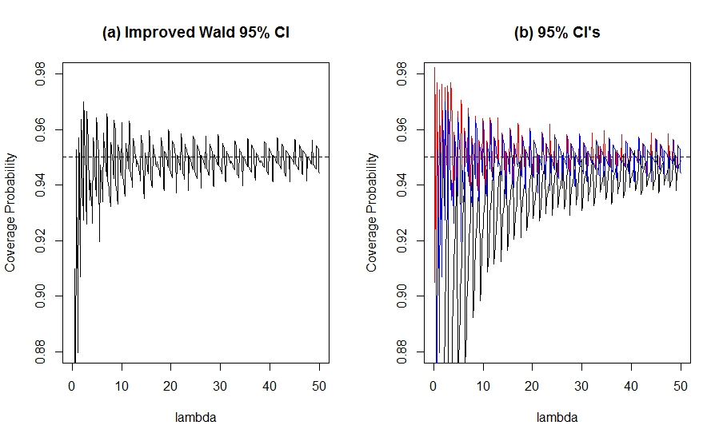

Figure 1 Plots for the actual coverage probability of (a) the Improved Wald interval for the nominal 95%. (b) Wald (black), Score (red) and Improved Wald (blue) for the nominal 95%.

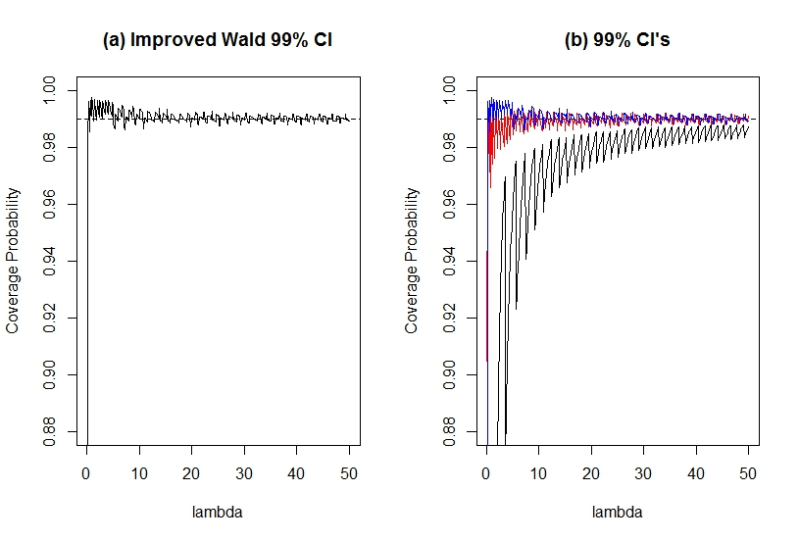

Figure 2 Plots for the actual coverage probability of (a) the Improved Wald interval for the nominal 99%. (b) Wald (black), Score (red) and Improved Wald (blue) for the nominal 99%.

The expected length of the three confidence intervals is also computed and plotted for $λ∈[0.01, 50]$. Figure 3(a) shows that the expected length of the new confidence interval is very close to the Score interval but still shorter, The same for the nominal 99%, the Wald interval is the shortest followed by the Improved Wald and then by the Score, but the Score interval width becomes wider than the expected width of the new confidence interval (see Figure 3(b)).

Furthermore, the expected length of the Wald, Improved Wald and Score confidence intervals are plotted against the actual coverage probability (Figure 4). It can be seen from the Figure 4(a)(b) that the Wald interval has shorter length than the other methods but it falls below the nominal confidence level, whereas the new method has a shorter expected length than the Score interval and maintain the nominal confidence level.

**Simulation Study**

In this section, a Monte Carlo simulation study was conducted in order to reinforce the above theoretical results for estimating the confidence interval for mean of Poisson distribution. Using R programming language [14], 30,000 Monte Carlo replications was calculated for different Poisson parameter ( $λ=0.5, 1, 3, 5, 10.)$ and different sample sizes ($n=10, 15, 30, 100.$). Then the average coverage probability as well as the average length of the confidence intervals was calculated for the nominal level of 95% and 99%.

The simulation results in Table 1 show that the new method has an average coverage probability greater than the Wald interval but very close to the Score interval. The new

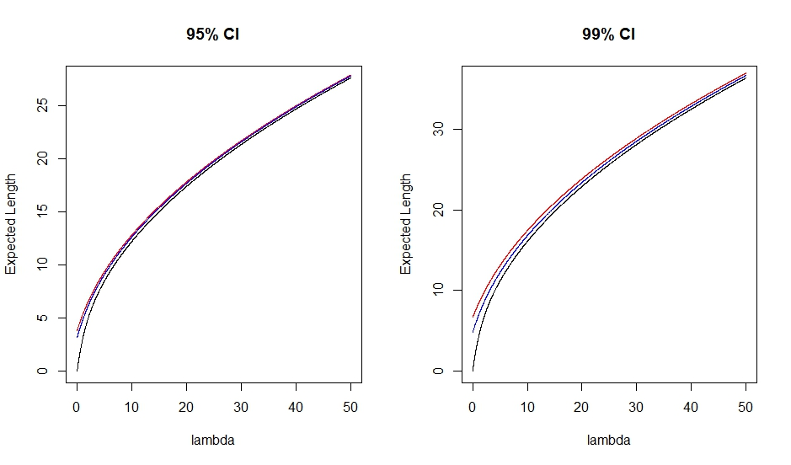

Figure 3 Plots for the expected width of the confidence interval of (a) Wald (black), Improved Wald (blue) and Score (red) for the nominal 95%. (b) Wald (black), Improved Wald (blue) and Score (red) for the nominal 99%

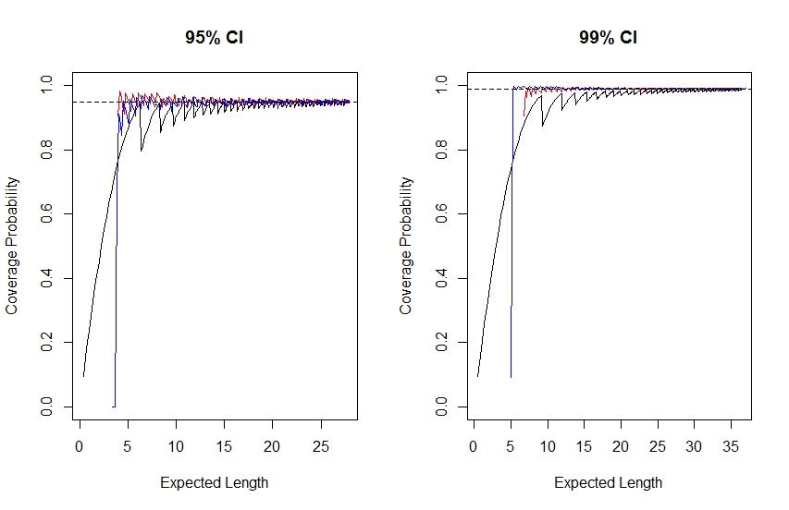

Figure 4 Plots show the expected width of the confidence interval for Wald (black), Score (red) and Improved Wald (blue) for the nominal (a) 95% and (b) 99%.

confidence interval is more stable and attains the nominal level even when the parameter is very small and the sample size is also small.

Although the improved Wald and the Score confidence interval has a greater advantage over the classical Wald confidence interval in terms of the coverage probability, table 2 shows that Wald confidence interval has the shortest average interval width. Nevertheless the Improved Wald interval has shorter average interval width than the Score interval.

Table 1 Table shows the estimated coverage probability of the Score, Wald and Improved Wald (New) confidence interval for nominal 95% and 99% at different lambda’s and different sample size.

|  |  |  |  |  |  |  |  |  |  |
| --- | --- | --- | --- | --- | --- | --- | --- | --- | --- |
|  |  |  | Nominal 95% | | |  | Nominal 99% | | |
| Sample size | $$λ$$ |  | **Score** | **Wald** | **New** |  | **Score** | **Wald** | **New** |
| 10 | **0.5** |  | 0.9620 | 0.8717 | 0.9620 |  | 0.9870 | 0.9608 | **0.9879** |
| **1** |  | 0.9638 | 0.9271 | 0.9638 |  | 0.9912 | 0.9704 | 0.9890 |
| **3** |  | 0.9462 | 0.9295 | 0.9462 |  | 0.9919 | 0.9863 | 0.9902 |
| **5** |  | 0.9439 | 0.9492 | 0.9439 |  | 0.9908 | 0.9871 | 0.9893 |
| **10** |  | 0.9493 | 0.9433 | 0.9493 |  | 0.9901 | 0.9883 | 0.9916 |
|  |  |  |  |  |  |  |  |  |  |
| 15 | **0.5** |  | 0.9336 | 0.9358 | 0.9336 |  | 0.9896 | 0.9418 | **0.9913** |
| **1** |  | 0.9502 | 0.9176 | 0.9502 |  | 0.9859 | 0.9809 | **0.9906** |
| **3** |  | 0.9575 | 0.9466 | 0.9575 |  | 0.9903 | 0.9863 | 0.9910 |
| **5** |  | 0.9426 | 0.9530 | 0.9426 |  | 0.9905 | 0.9882 | 0.9903 |
| **10** |  | 0.9554 | 0.9527 | 0.9506 |  | 0.9900 | 0.9889 | 0.9898 |
|  |  |  |  |  |  |  |  |  |  |
| 30 | **0.5** |  | 0.9521 | 0.9215 | 0.9521 |  | 0.9882 | 0.9810 | **0.9926** |
| **1** |  | 0.9471 | 0.9306 | 0.9471 |  | 0.9920 | 0.9842 | 0.9900 |
| **3** |  | 0.9495 | 0.9456 | 0.9495 |  | 0.9908 | 0.9875 | 0.9906 |
| **5** |  | 0.9533 | 0.9514 | 0.9484 |  | 0.9890 | 0.9890 | **0.9891** |
| **10** |  | 0.9472 | 0.9498 | 0.9472 |  | 0.9903 | 0.9906 | 0.9904 |
|  |  |  |  |  |  |  |  |  |  |
| 100 | **0.5** |  | 0.9460 | 0.9498 | 0.9460 |  | 0.9905 | 0.9875 | 0.9884 |
| **1** |  | 0.9484 | 0.9434 | 0.9484 |  | 0.9889 | 0.9869 | **0.9906** |
| **3** |  | 0.9480 | 0.9508 | 0.9480 |  | 0.9900 | 0.9887 | 0.9897 |
| **5** |  | 0.9472 | 0.9467 | 0.9472 |  | 0.9908 | 0.9908 | 0.9908 |
| **10** |  | 0.9492 | 0.9520 | 0.9511 |  | 0.9899 | 0.9896 | 0.9898 |

Table 2 Shows the estimated length of the Score, Wald and Improved Wald confidence intervals for nominal 95% and 99%, for different lambda’s and different sample sizes.

|  |  |  |  |  |  |  |  |  |  |
| --- | --- | --- | --- | --- | --- | --- | --- | --- | --- |
|  |  |  | Nominal 95% | | |  | Nominal 99% | | |
| Sample size | $$λ$$ |  | **Score** | **Wald** | **New** |  | **Score** | **Wald** | **New** |
| 10 | **0.5** |  | 0.931 | 0.901 | 0.905 |  | 1.302 | 1.145 | 1.223 |
| **1** |  | 1.279 | 1.250 | 1.260 |  | 1.738 | 1.628 | 1.676 |
| **3** |  | 2.167 | 2.151 | 2.156 |  | 2.884 | 2.817 | 2.848 |
| **5** |  | 2.789 | 2.773 | 2.781 |  | 3.692 | 3.639 | 3.664 |
| **10** |  | 3.931 | 3.922 | 3.925 |  | 5.186 | 5.149 | 5.166 |
|  |  |  |  |  |  |  |  |  |  |
| 15 | **0.5** |  | 0.744 | 0.719 | 0.730 |  | 1.024 | 0.948 | 0.980 |
| **1** |  | 1.032 | 1.018 | 1.022 |  | 1.389 | 1.327 | 1.356 |
| **3** |  | 1.765 | 1.756 | 1.759 |  | 2.338 | 2.301 | 2.319 |
| **5** |  | 2.273 | 2.266 | 2.269 |  | 3.000 | 2.971 | 2.985 |
| **10** |  | 3.207 | 3.201 | 3.202 |  | 4.226 | 4.206 | 4.216 |
|  |  |  |  |  |  |  |  |  |  |
| 30 | **0.5** |  | 0.517 | 0.510 | 0.512 |  | 0.695 | 0.664 | 0.679 |
| **1** |  | 0.723 | 0.718 | 0.719 |  | 0.961 | 0.939 | 0.949 |
| **3** |  | 1.244 | 1.241 | 1.242 |  | 1.641 | 1.628 | 1.634 |
| **5** |  | 1.603 | 1.600 | 1.601 |  | 2.113 | 2.103 | 2.108 |
| **10** |  | 2.265 | 2.263 | 2.264 |  | 2.980 | 2.974 | 2.977 |
|  |  |  |  |  |  |  |  |  |  |
| 100 | **0.5** |  | 0.279 | 0.277 | 0.278 |  | 0.369 | 0.364 | 0.367 |
| **1** |  | 0.393 | 0.392 | 0.393 |  | 0.519 | 0.515 | 0.517 |
| **3** |  | 0.680 | 0.679 | 0.679 |  | 0.894 | 0.892 | 0.893 |
| **5** |  | 0.877 | 0.877 | 0.877 |  | 1.153 | 1.152 | 1.153 |
| **10** |  | 1.240 | 1.240 | 1.240 |  | 1.630 | 1.629 | 1.630 |

**CONCLUSION**

The Wald and the Score intervals are the most common methods in estimating the confidence interval for the Poisson mean, but the Wald interval raises a concern among statisticians when $λ$ is small. The Improved Wald interval is recommended to be used, since it has a coverage probability closer to the nominal levels than the classical Wald interval. In addition , it has a smaller coverage width than the Score interval.

**REFERENCES**

[1]. Santner T. J.; A Note on Teaching Binomial Confidence Limits., Annals of Mathematical Statistics, 1998, **20**: 20-23.

[2]. Ghosh B. K.; A Comparison of Some Approximate Confidence Intervals for the Binomial Parameter., Journal of the American Statistical Association, 1979, **74**: 894-900.

[3]. Agresti A. and Coull B.; Approximate Is Better than Exact for Interval Estimation of Binomial Proportions., The American Statistician, 1998, **52**:119-126.

[4]. Blyth C. R., and Still H. A.; Binomial Confidence Interval., Journal of the American Statistical Association, 1983, **78**: 108-116.

[5]. Wilson E. B.; Probable Inference, the Law of Succession, and Statistical Inference., Journal of the American Statistical Association, 1927, **22**: 209-212.

[6]. Schader M., and Schmid F.; Charting Small Sample Characteristics of Asymptotic Confidence Interval for the Binomial Parameter $p$.; Statist. Papers, 1990, **31**: 251-264.

[7]. Brown L. D., Cai T. T., and DasGupta A.; Confidence Intervals for a Binomial Proportion and Asymptotic Expansion., The Annals of Statistics, 2002, **30**:160-201.

[8]. Bartlett M.S.; The Square Root Transformation in the Analysis of Variance., Journal of Royal Statistical Society Supplement 3, 1936, 68-78.

[9]. Begaud B., Karin M., Abdelilah A., Pascale T., Nicholas M., and Yola M.; An Easy to Use Method to Approximate Poisson Confidence Limits., European Journal of Epidemiology, 2005, **20**(3): 213-216.

[10]. Schwerman N. C., and Martinez R. A.; Approximate Poisson confidence limits., Communication in Statistics – Theory and Methods., 1994, **23**(5): 1507-1529.

[11]. Barker L. A.; Comparison of Nine Confidence Intervals for a Poisson Parameter When the Expected Number of Events Is $≤5$., The American Statistician, 2002, **56**:85-89.

[12]. Khamkong M.; Approximate Confidence Interval for the Mean of Poisson Distribution., Open Journal of Statistics, 2012, **2**: 204-207

[13]. G. Casella and R. L. Berger, “Statistical Inference” 2nd Edition, Wadsworth, West Yorkshire, 2002.

[14]. R Core Team. R: A language and environment for statistical computing. R Foundation for Statistical Computing, Vienna, Austria. 2013.